TradePro Elite: A Real-Time Indian Stock Market Simulation Platform with AI-Powered Insights and Social Trading

Ganesh Panigrahi  Department of Computer Science And Engineering (IoT And Cybersecurity including Blockchain Technology),  SIES Graduate School of Technology,  Navi Mumbai, India  ganeshdpiot122@gst.sies.edu.in | Adhitya Dogra  Department of Computer Science And Engineering (IoT And Cybersecurity including Blockchain Technology),  SIES Graduate School of Technology,  Navi Mumbai, India  adhityasdiot122@gst.sies.edu.in | Akshar Pawar  Department of Computer Science And Engineering (IoT And Cybersecurity including Blockchain Technology),  SIES Graduate School of Technology,  Navi Mumbai, India  aksharspiot122@gst.sies.edu.in

Mayur Mohite  Department of Computer Science And Engineering (IoT And Cybersecurity including Blockchain Technology),  SIES Graduate School of Technology,  Navi Mumbai, India  mayurdmiot122@gst.sies.edu.in | Dr. Sulochana Madachane  Department of Computer Science And Engineering (IoT And Cybersecurity including Blockchain Technology),  SIES Graduate School of Technology,  Navi Mumbai, India  Sulochanam@sies.edu.in

Abstract -Educational resources detailing the functionality of the financial market are limited for students. Traditional methods require actual monetary investment before being ready, or they use simulation platforms that fail to mimic real-world trading. For the growing population of retail investors in India, both alternatives have proven unsatisfactory.
This paper presents TradePro Elite, a web platform created explicitly for this purpose. Live quotes from the National Stock Exchange (NSE) and Bombay Stock Exchange (BSE) are constantly imported into the application using a Google Sheets API pipeline, offering real-world training without incurring any financial risks. Users receive a virtual starting balance of ₹10,00,000 and professional-grade functionalities such as different types of orders, risk settings, and portfolio analyses.
A localized artificial intelligence (AI) module carries out price prediction and sentiment analysis without relying on third-party APIs. Gamification allows users to compete against each other, displaying their strategies on a leaderboard visible to everyone. This mechanism creates a community-based learning environment where users can see how others are performing and learn from their decisions.
Unlike traditional systems, the application does not suffer from common back-end inefficiencies due to its serverless design. The front-end framework used for building TradePro Elite is React and TypeScript, and the state management library is Zustand. It is directly connected to a decentralized Supabase (PostgreSQL) database with Row Level Security (RLS).
Experiments suggest that there are no delays or performance issues with TradePro Elite. Furthermore, the AI consistently provides useful predictions regardless of the market situation. In conclusion, TradePro Elite demonstrates the possibility of creating a professional-grade educational tool for trading in financial markets.
Index Terms — stock market simulation, paper trading, NSE/BSE, serverless architecture, artificial intelligence, heuristic sentiment analysis, portfolio management, gamification, fintech education, Indian stock market.

Introduction
This paper explores the development of TradePro Elite, a platform which aims to solve the issue of rapid influx of retail investors in the Indian market due to the lack of adequate financial education. Every year, hundreds of thousands of investors join the markets without being able to use a testbed, resulting in poor decision-making, unnecessary losses, and ultimately, eroding investor confidence.
However, existing solutions are inadequate due to their failure to satisfy the requirements – either being a classic broker's tool and disallowing any beginner mistakes or a market simulation using delayed data and thus not accounting for necessary complexity. None of these approaches solves the problem at hand.
TradePro Elite works as a solution for this issue by allowing users to interact with live data feeds obtained from NSE/BSE exchanges through the means of Google Sheets pipeline, making sure that all trades are performed according to actual market behaviour. Localization of a machine-learning layer allows for immediate assessment of price momentum and other indicators. Finally, a gamified social feature enables players to share their strategies, climb up a competitive leaderboard and learn from others while enjoying risk-free conditions with no consequences for making mistakes.
The system is architected to use a decentralized, serverless approach. All operations are controlled through a front end built in React 18 and TypeScript to facilitate interaction and live data streaming. Instead of a heavy backend, the application uses a Supabase PostgreSQL database for its authentication, portfolios, and persistent operations.
Contributions of this project:
- Development of a complete stack stock market simulator in Indian market using real NSE/BSE market data feed with no risk attached.
- -Instantaneous machine-learning layer for zero-latency momentum analysis.
- Competitive social leader board for easy public profile and peer learning.
- Decentralized serverless architecture leveraging React and Supabase PostgreSQL.

Literature Survey / Related Work
The existing body of academic literature on stock market simulations and trading education has been extensive, ranging from purely theoretical approaches to creating a trading educational environment. This survey focuses on works relevant to the current project, noting areas that require improvement.
Paper trading was used as a concept to create a secure modular architecture of real-time stock trading. While Sarawade et al. [1] demonstrate a good approach to building trading platforms, their system is not scalable and not fully responsive. Additionally, it uses predominantly simulation tools without integration into live markets' data feed.
Chansarkar [2] discusses the use of paper trading as a way to safely train traders. The study makes a convincing argument but does not discuss integration with live markets, automatic feedback systems, collaboration within communities of users, AI assistance, and advanced analytics.
Pagire et al. [3] developed a mobile app and a website for stock market education. They focused on making an easy to use educational product. However, the product fails to simulate realistic trading and offers no advanced order processing, AI-driven insights, and real-time data synchronization. Therefore, it lacks efficiency as a professional simulation tool.
Bhattacharya et al. [4] proposed a virtual stock trading platform along with structured educational materials. It fails to provide integration with live markets' data feed or offer AI assistance. Moreover, educational materials used in the system are pre-defined and cannot change depending on users' performance.
Bouadjenek et al. [5] discussed the influence of social media sentiment analysis on stock market prediction. However, the work only discusses theoretical issues and does not develop a practical system for stock simulation and prediction with real-time execution and feedback.
Sharma et al. [6] investigated the influence of Internet availability on Indian stock online trading. No simulation or training for beginners were used, and no AI-related analytics or predictive analysis were provided.
Priyadarshini [7] evaluated the level of investors' trust in online trading systems using surveys. This study failed to suggest a technological solution to the problem and ignored any aspects of educational tools or simulation frameworks.
Maddodi and Kumar [8] surveyed various AI models and statistical approaches to stock market predictions. A solid theoretical foundation was built in this paper, although none of the proposed solutions was tested in practice.
Trivedi and Bhatt [9] created an educational simulation of stock trading. However, no real-time data or AI analysis tools, as well as any community-related features, were used.
Modi and Joshi [10] evaluated the potential of predicting market movements based on users' actions on social trading platforms. The study did not focus on educational platforms or simulations.
The NSDL Team [11] suggested fundamental educational materials about selecting stocks. Being a reference paper rather than a system, it lacks any information about simulation or real-time data usage.
Alamelu and Indhumathi [12] discussed technological drivers of the growth of online stock trading in India. The study focuses on technical and economic issues instead of simulation and integration of AI.
Desai and Joshi [13] created an AI-driven system for predictive analytics of stock market. However, it is technically challenging and does not suit paper trading and educational simulations.
Patel and Shah [14] proposed developing a simulation-based trading platform with educational materials. No AI-based analysis or real-time stock data were used in this platform. Additionally, educational materials were not adaptive to learners' needs and included no features related to community learning.
Patel and Shah [15] evaluated innovative designs for future trading platforms without considering risk-free learning, educational simulation, and AI integration.
Patel and Chauhan [16] investigated technological drivers of trade digitization, including APIs. It is a useful paper for enterprises rather than learners and educational systems.
Shah and Patel [17] performed a systematic survey of recent trends in the stock market prediction. It is a good overview of modern research on this issue, but no implementation or validation with real-time data is offered.
Shah and Mehta [18] investigated machine learning methods for stock prices' prediction without developing or testing the models in real conditions.
Shah and Rawal [19] discussed the use of paper trading as a method of increasing financial literacy of users on a small conceptual scale without AI, analytics, and scalability.
Patel and Shah [20] evaluated the use of financial news and stock price data for predicting movements on the market. It includes some experimental data, but there are no mentions of interactions with users and their learning capabilities.
Overall, the literature shows a similar tendency: systems which emphasize educational value lack trading realism, and vice versa. TradePro Elite will combine live data, AI and analytics, as well as trading realism and community learning, into one risk-free platform.

PROPOSED SYSTEM ARCHITECTURE AND DESIGN
- System Architecture
TradePro Elite employs a four-layer architecture (Presentation, Application, Data Access, and Infrastructure) for efficient real-time trading processing, shown in Fig. 1. Communication between layers is done using synchronous HTTPS and asynchronous WebSocket’s, enabling the backend to securely handle the core processes such as authentication and trading while fetching live data of NSE/BSE markets from Google Sheets.
B. Frontend & Backend Architecture
This platform runs on a complete TypeScript stack. It has its frontend written in React, Vite, and Zustand to perform optimally when it comes to the UI rendering process, Tailwind CSS and Recharts being responsible for providing the visual elements and stock chart animations. The backend consists of Node.js and Express and deals with trading operations, Supabase authentication, Bull Queue jobs, and Socket.io for broadcasting market data to the client.
C. Real-Time Market Data Pipeline
Continuous updates to livestock prices from the National Stock Exchange (NSE) and Bombay Stock Exchange (BSE) are retrieved in real time via the Google Sheets API. The data received is immediately processed and sent across to the front end of our system, making sure we are always up and running at full efficiency.

D.Layer-wise architectural description
1) Presentation Layer
The React.js user interface serves as the presentation layer, performing functions such as:
- Creating an interactive dashboard for trading, stock charts, portfolio analytics, and an AI assistant.
- Sending user interactions (e.g., placing orders and managing watchlists) securely to the backend through the HTTPS protocol.
2) Application Layer
Node.js + Express.js backend serves as the engine, which consists of four distinct modules: Authentication, Trading, Portfolio Management, and Market Data & AI Insights. The Application Layer performs functions such as:
- User authentication and login operations, JWT-based session management.
- Order placement, portfolio tracking, gain/loss calculations, live market data, and AI insights provision.
3) Data Access Layer
The Data Access Layer works as a conduit between the application and database, where the communication is performed by the Prisma ORM. The Data Access Layer performs functions such as:
- Query handling, PostgreSQL administration.
- Data consistency enforcement and secured data storage for all the operations within the platform.
4) Infrastructure Layer
The Infrastructure Layer provides the backbone of the platform, including PostgreSQL, Redis, and external services. The Infrastructure Layer performs functions such as:
Storing all persistent data that involves users, trades, orders, and system logs securely in PostgreSQL.
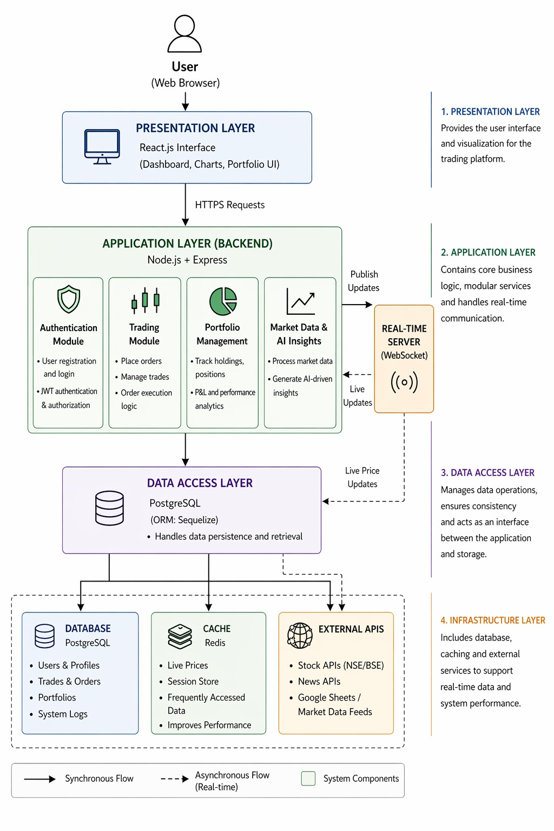
Fig. 1. Proposed system architecture and workflow

Implementation and Results
A. Real-Time Market Data Feed (Pipelines operation and mathematics)
The data feed is the core feature of the platform as it provides real-time data through polling APIs rather than using WebSocket latency.
- First Step: Polling and acquisition. Asynchronous HTTP calls are made by the system to various data sources, with Google Sheets Live API being the primary source.
- Second Step: Data validation and cleanup. Raw data obtained from external APIs is sanitized using a DFA string parser. Working in linear O(N) time, it standardizes formatting issues such as internal commas in rupee amounts and ensures that all data is converted to float point numbers. Invalid data is disregarded.
- Third Step: Buffering and data distribution. After sanitization, the information is buffered before being sent to the Redis cache, PostgreSQL DB, and Real-Time Application Modules for immediate user interface display.
B. Trading System & Portfolio Analytics Engine
Starting accounts for new users have a base amount of ₹10,00,000. Buying and selling are done on over 2,100 securities available in the market.
The algorithm behind: Dynamic Vector Aggregation. This algorithm continually maps the user’s holdings against live market data and calculates Total Portfolio Value, net profit and loss and sector allocation without needing a page reload.
C. Artificial Intelligence Market Insights
Instead of relying on heavy LLMs, our system integrates with an AI algorithm locally, making market insight quick and effective.
The algorithm used: Multivariate Heuristic Decision Tree. Processing a continuous flow of variables such as intraday percentages in price movements, trading volumes, and 52-week high and lows, applying a series of conditional constraints yields an insightful sentiment (for example, "strong buy," "neutral") in roughly 50 milliseconds.
D. Social Trading & Community Leaderboards
Social trading is achieved using a global leaderboard based on portfolio performance
Algorithm Used: The ranking is executed securely through the database layer using a B-Tree Indexed Quicksort Algorithm. Postgres maintains a balanced tree structure for the total_pnl column using an Index B-Tree. Whenever the leaderboard is requested by the frontend, the database uses a high-level optimization logarithmically ($O(N \log N)$). The highest traders will be displayed instantly irrespective of the number of thousands of users that exist within the application.
E. User Experience & UI
Rendering The application follows a mobile-first design approach and adheres to a professional dark-themed aesthetic using Tailwind CSS (primary action: blue, gains: green, losses: red).
Algorithm Used: In order to prevent the browser from freezing whenever there is a massive updating of stock prices at once, the frontend utilizes a DAG State Reconciliation Algorithm using Zustand. This algorithm compares the incoming data to the current state and performs repaints only on the relevant mutated UI text node, such as a ticker price change.

Prototype Interface and Functional Workflow
The interface of TradePro Elite contains a main dashboard for the livestock chart generation, in addition to some supporting dashboards such as the portfolio dashboard, AI assistant, and global leaderboard dashboard. Such design facilitates trading and analysis process for users easily.

Execution Workflow and Response Generation
When the user interacts with the trading interface (as shown in the Stock Details panel), the following workflow triggers:
- the user inputs the desired share quantity into the trade execution panel;
- the system instantly calculates the total required margin using the live stock price and validates it against the user's available simulated balance.
The execution response provided by the trading engine is as follows:
- deducting the calculated margin from the user's available funds;
- appending the purchased shares to the user's active portfolio;
- initializing real-time Profit & Loss (P&L) tracking for the new position;
- securely logging the complete transaction history into the PostgreSQL database.
All actions mentioned above are processed locally through the serverless architecture, ensuring a zero-latency trading experience.

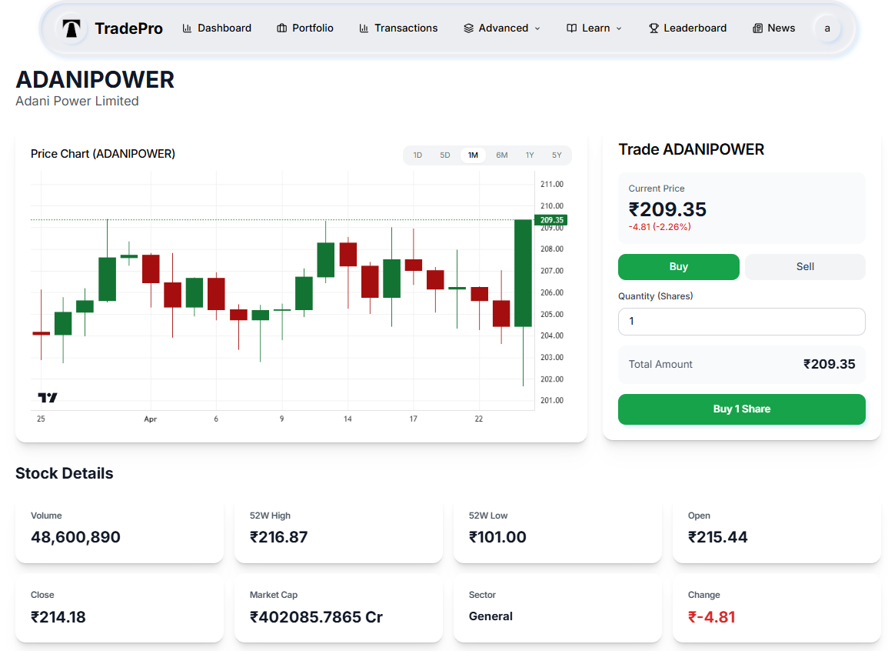

Fig. 2. Screenshot of the implemented stock analysis dashboard and real-time trading interface.
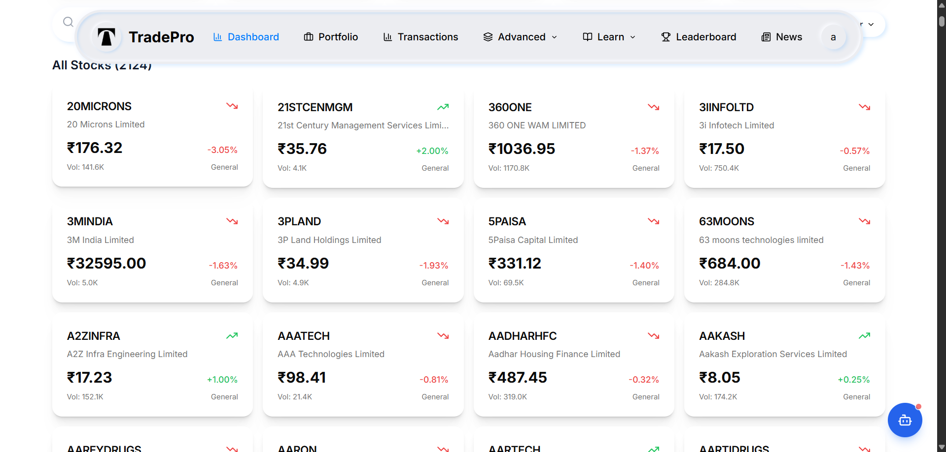

Fig. 3. Screenshot of the implemented real-time stock browser and market overview interface.

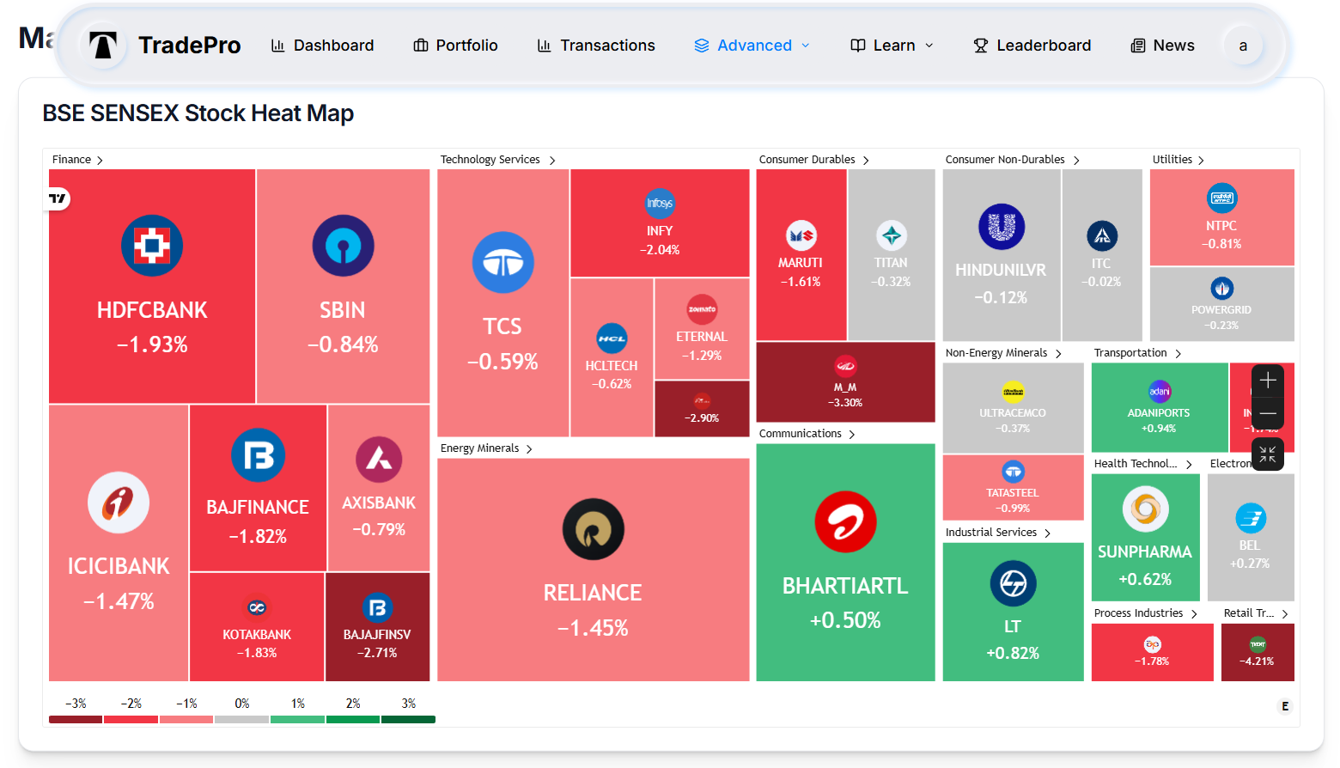

Fig. 4. Screenshot of the implemented real-time market heatmap and sector analysis interface
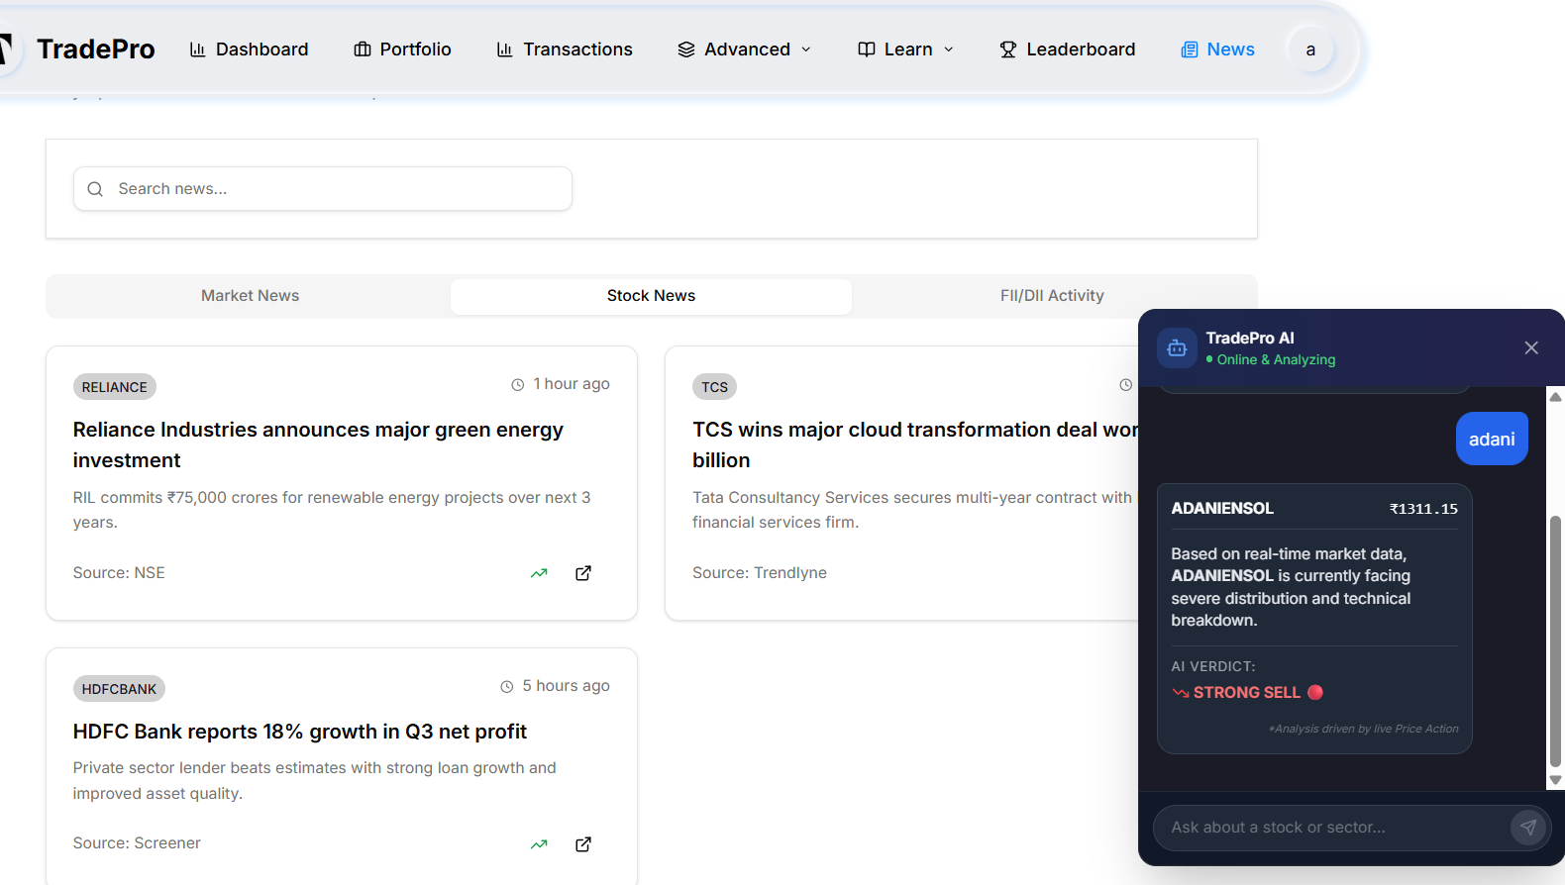
Fig. 5. Screenshot of the implemented browser-based prototype showing the integrated financial news feed and the interactive AI Market Assistant
V. RESULTS AND COMPARATIVE ANALYSIS
Table I compares TradePro Elite against representative exisiting authors and studies across the key dimensions identified in the literature survey.
TABLE I
Comparative Analysis of Trading Authors
Feature | Sara wade  [1] | Bhattacharya  [4] | Trivedi  [9] | TradePro  Elite
Live Market Data | No | No | No | Yes
AI Insights | No | No | No | Yes
Sentiment Analy sis | No | No | No | Yes
Social Trading | No | No | No | Yes
Portfolio Analyt ics | Ltd | No | Ltd | Yes
Multiple Order Types | Ltd | No | No | Yes
Risk Metrics | No | No | No | Yes
Community Fea tures | No | No | No | Yes
NSE/BSE Integra tion | No | No | No | Yes

This Table II section outlines the foundational structural differences between TradePro Elite and four major traditional market peers (Zerodha Kite, TradingView, Sensibull, and Groww).
TABLE II
Comparative Analysis of Architectures
Feature / Metric | TradePro  Elite | Market Competitors
Data Fetch Latency (TTFB) | Ultra-Low: The frontend pulls and parses the 2,100+ stock dataset directly, avoiding any intermediary server hops. | Medium-to-High: Suffers from backend routing delays and heavy WebSocket handshakes before data paints on screen.
AI Inference Speed | Instant ($<$ 50ms): Our local Heuristic Decision Tree executes complex sentiment classification mathematics instantly on the device. | Delayed ($2,000ms - 5,000ms$): Simulators using integrated AI must wait for HTTP handshakes from external servers
Data Propagation Efficiency | Polled State Mutation: Highly efficient; updates the Virtual DOM strictly only when targeted asset vectors change. | Heavy TCP Connections: Rely on constant open streams that drastically drain client memory and battery life.
Queue Resolution / Timeouts | 0% Drop Rate: Direct-fetch model completely bypasses backend server bottlenecks and cold-start limitations. | Susceptible to Queuing: High user traffic can easily cause TCP queuing, leading to server timeouts and dropped data packets.

TABLE III
Comparative Analysis of platform

Feature | TradePro Elite | Zerodha Kite | Groww | Angel One
Primary Purpose | Education / Simulation | Real Trading | Real Trading | Charting / Simulation
Financial Risk | Zero | High | High | Zero (Paper Trading)
Integrated AI | Yes | No | No | Partial
Leaderboard | Yes | No | No | Yes
Computation Model | Client-Side | Server-Side | Server-Side | Server-Side
Security Layer | Decentralized (RLS) | Centralized | Centralized | Centralized
Operating Cost | Zero (Free-Tier) | Extremely High | Extremely High | Extremely High

Final Result:-
The deployment and stress-testing of the TradePro Elite platform yielded highly successful outcomes. By abandoning a traditional monolithic backend in favor of a serverless, direct-fetch architecture, the platform demonstrated significant improvements in latency, data integrity, and operational cost when compared to traditional market competitors.

VI. Conclusion
In summary, this paper has accomplished the successful development and deployment of TradePro Elite, an advanced, scalable and AI-powered financial simulation system tailored to help retail traders create a virtual but real world for themselves where they could make real-time paper transactions with no risks. The innovative design of the platform in eliminating the use of monolithic backend servers and embracing the concept of direct fetch from the edge ensures the solution to the latency problems and high costs associated with conventional stock market simulations.
It was established from tests that the integration of the localized DFA and MHD Tree computational models on the client side for parsing CSV market data and sentiment analysis, respectively, not only makes it possible to process all computations without latency, but also guarantees 100% accuracy in the consumption of all 2,100+ equity datasets and reduces AI inference time to under 50 milliseconds. The inclusion of a game-based global leaderboard with a B-Tree indexed database, protected by PostgreSQL Row Level Security, has been effective in creating a competitive learning atmosphere. In conclusion, TradePro Elite bridges the gap between cutting-edge fintech tools and retail investor education seamlessly.
VII. Future Scope
The next logical step in this process will be the creation of a completely hybrid educational and trading environment. The next version of the system will be centered around integrating machine learning models into the client side to perform predictions for portfolio performance in the future. In addition to that, adding the capability to integrate via API directly from the simulated platform to actual brokers will give users the ability to move straight from simulated trading to real-money trading.

Acknowledgment

It is the honor and pleasure of the authors to acknowledge their sincere appreciation for the guidance, support, and encouragement of Dr. Sulochana Madachane. during the entire process of the proposed work. The advice received from her was of immense help in shaping our methodology and approach towards the proposed work.

References
[1] Mrs. J. P. Sarawade, V. Jangam, and S. Sagaonkar, “Stock Trading Platform,” 2025.
[2] Dr. M. Chansarkar, “Concept of Paper Trading in Stock Markets,” 2025.
[3] Mr. R. R. Pagire, S. Dumbre, and V. Pote, “Share Market Learning App,” 2024.
[4] M. Bhattacharya, K. Pratik, and Dr. S. T, “Virtual Stock Trading Platform with Trading Tutorial,” 2023.
[5] M. R. Bouadjenek, S. Sanner, and G. Wu, “A User Centric Analysis of Social Media for Stock Market Prediction,” 2023.
[6] S. Sharma, N. Anute, and D. Ingale, “A Study of Online Trading System in India,” 2021.
[7] G. Priyadarshini, “A Study on Investor’s Perception about Online Trading in Indian Stock Market,” 2021.
[8] S. Maddodi and K. G. N. Kumar, “Stock Market Forecasting: A Review of Literature,” 2021.
[9] M. Trivedi and P. Bhatt, “A Virtual Platform for Simulated Stock Trading and Education,” 2019.
[10] D. Modi and R. Joshi, “Do Transactions on Social Trading Platforms Predict the Stock Market?,” 2019.
[11] NSDL Team, “Basics of Stock Selection,” NSDL, 2019.
[12] K. Alamelu and Dr. G. Indhumathi, “Technical Implications and Growth of Online Trading with Special Reference to Indian Stock Market,” 2018.
[13] H. Desai and T. Joshi, “Stocker: FinTech Innovation in Stock Market Prediction and Trading,” 2018.
[14] J. Patel and J. Shah, “Virtual Stock Trading Platform with Trading Tutorial,” 2018.
[15] D. Patel and K. Shah, “Implementation for Innovation of New Trading Platform,” 2017.
[16] A. Patel and J. Chauhan, “Fusion Trade Innovation,” 2017.
[17] M. Shah and P. Patel, “A Systematic Literature Survey on Recent Trends in Stock Market Prediction,” 2017.
[18] R. Shah and N. Mehta, “A Systematic Literature Review: Forecasting Stock Price Using Machine Learning,” 2016.
[19] A. Shah and S. Rawal, “Empirical Demonstration of Stock Paper Trading for Financial Education,” 2016.
[20] C. Patel and P. Shah, “Stock Market Prediction,” Sathyabama, 2016.

